John Lee & Ravi Gupta

ICS 499

Ryan Hankins

2/27/18

Requirement Documents: Online Banking System

**Requirements:**

Our objective is to provide these possible online services within our bank:

**Customers**

* Customers can login in the main page.
* Customers view or edit their account details.
* Customers can transfer their funds to another person account associated with our bank.
* Customers can view account statements.
* Customers can view balance enquiry.
* Customers can request for ATM cards and cheque books.
* Customers can add beneficiary to their account.
* Customers can change their own passwords.

**Admins**

* Admins have a hidden page login.
* Admins can add new staff/customers into the staff and customers database.
* Admins can individually delete staff/customers database.
* Admins can individually edit staff/customers database.
* Admins can change his/her own password.

**Staff**

* Staff have separate login page.
* Staff view their account details.
* Staff approve beneficiary requests.
* Staff approve ATM card requests.
* Staff can change their passwords.

Software Requirements: XAMPP 5.6.32, Apache 2.4.3, MYSQL 5.5, and Operating System Windows 7 or higher.

Use Cases:

Customer Use Case

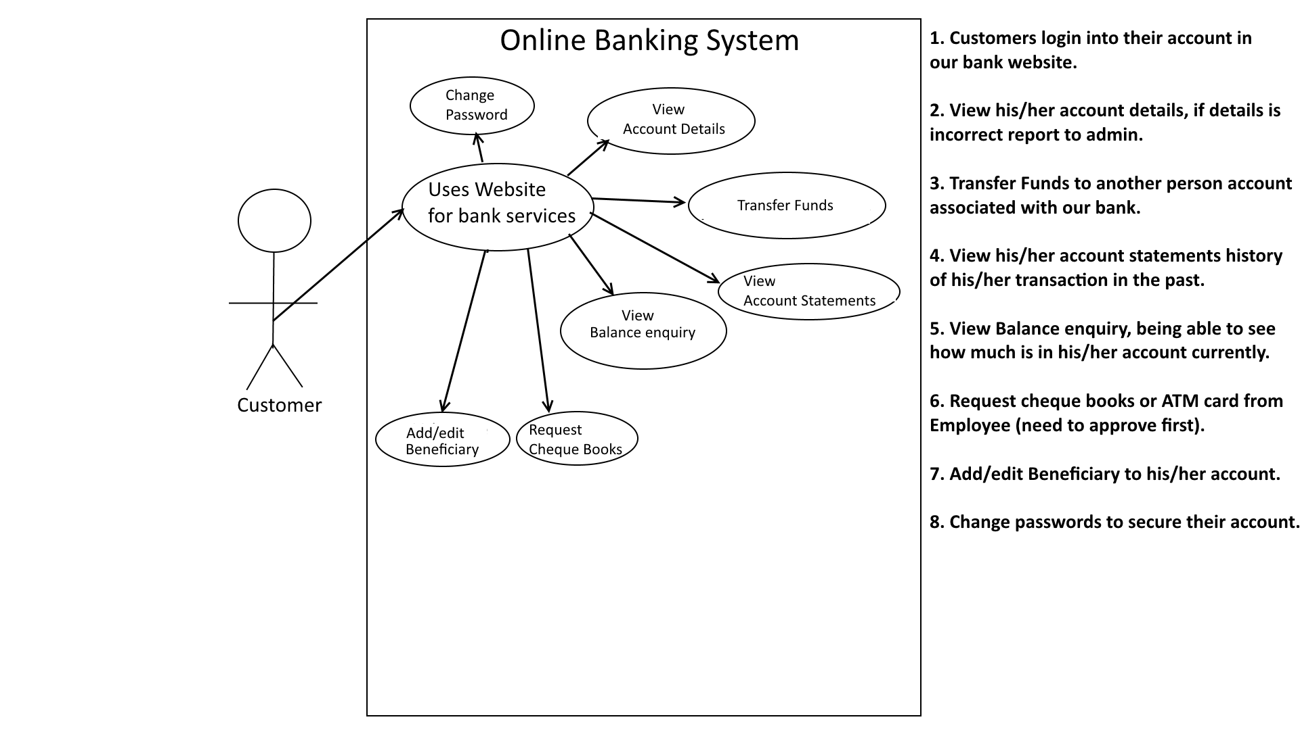

Admin Use Case

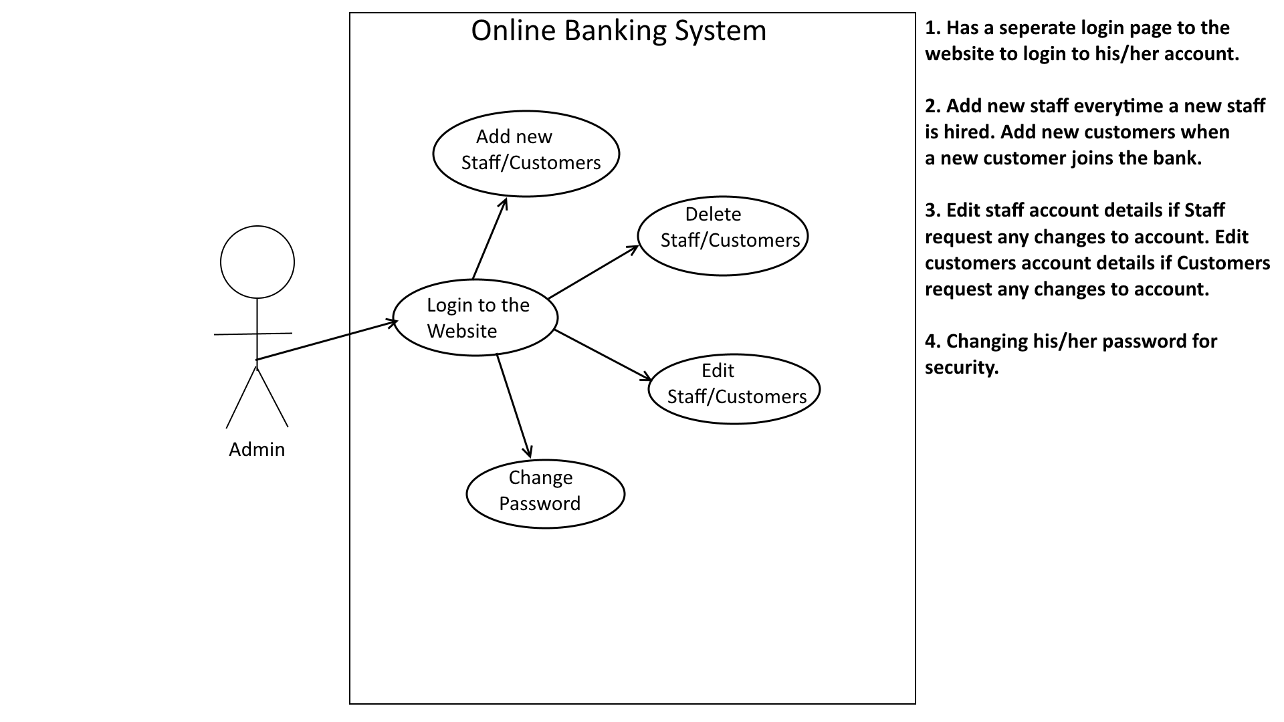

Staff Use Case

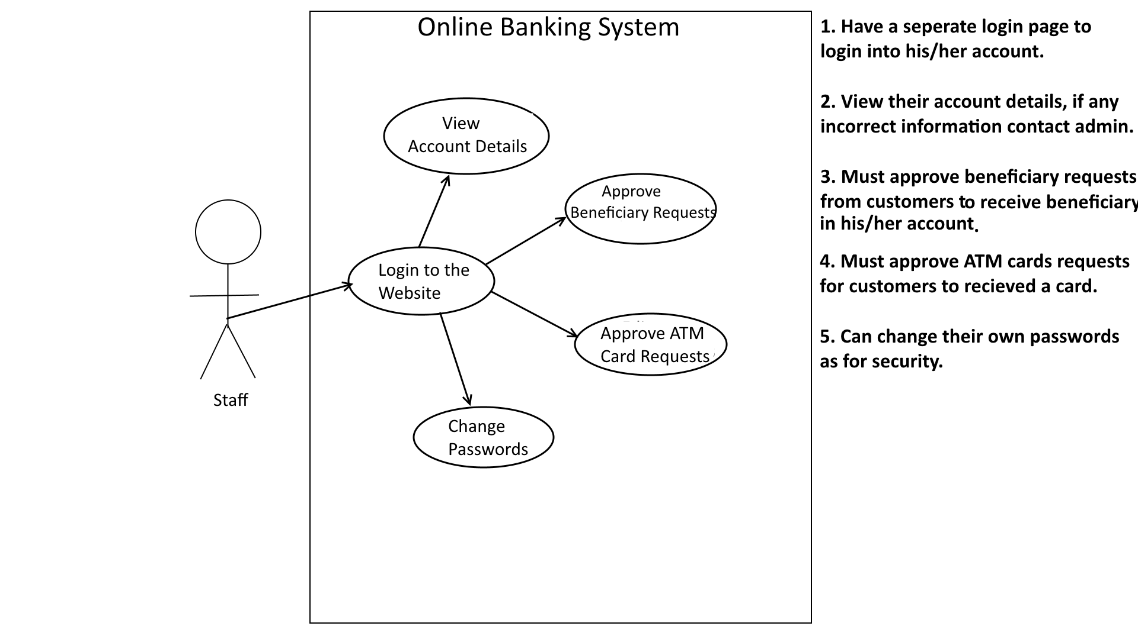

Updated Use Case:

Customer:

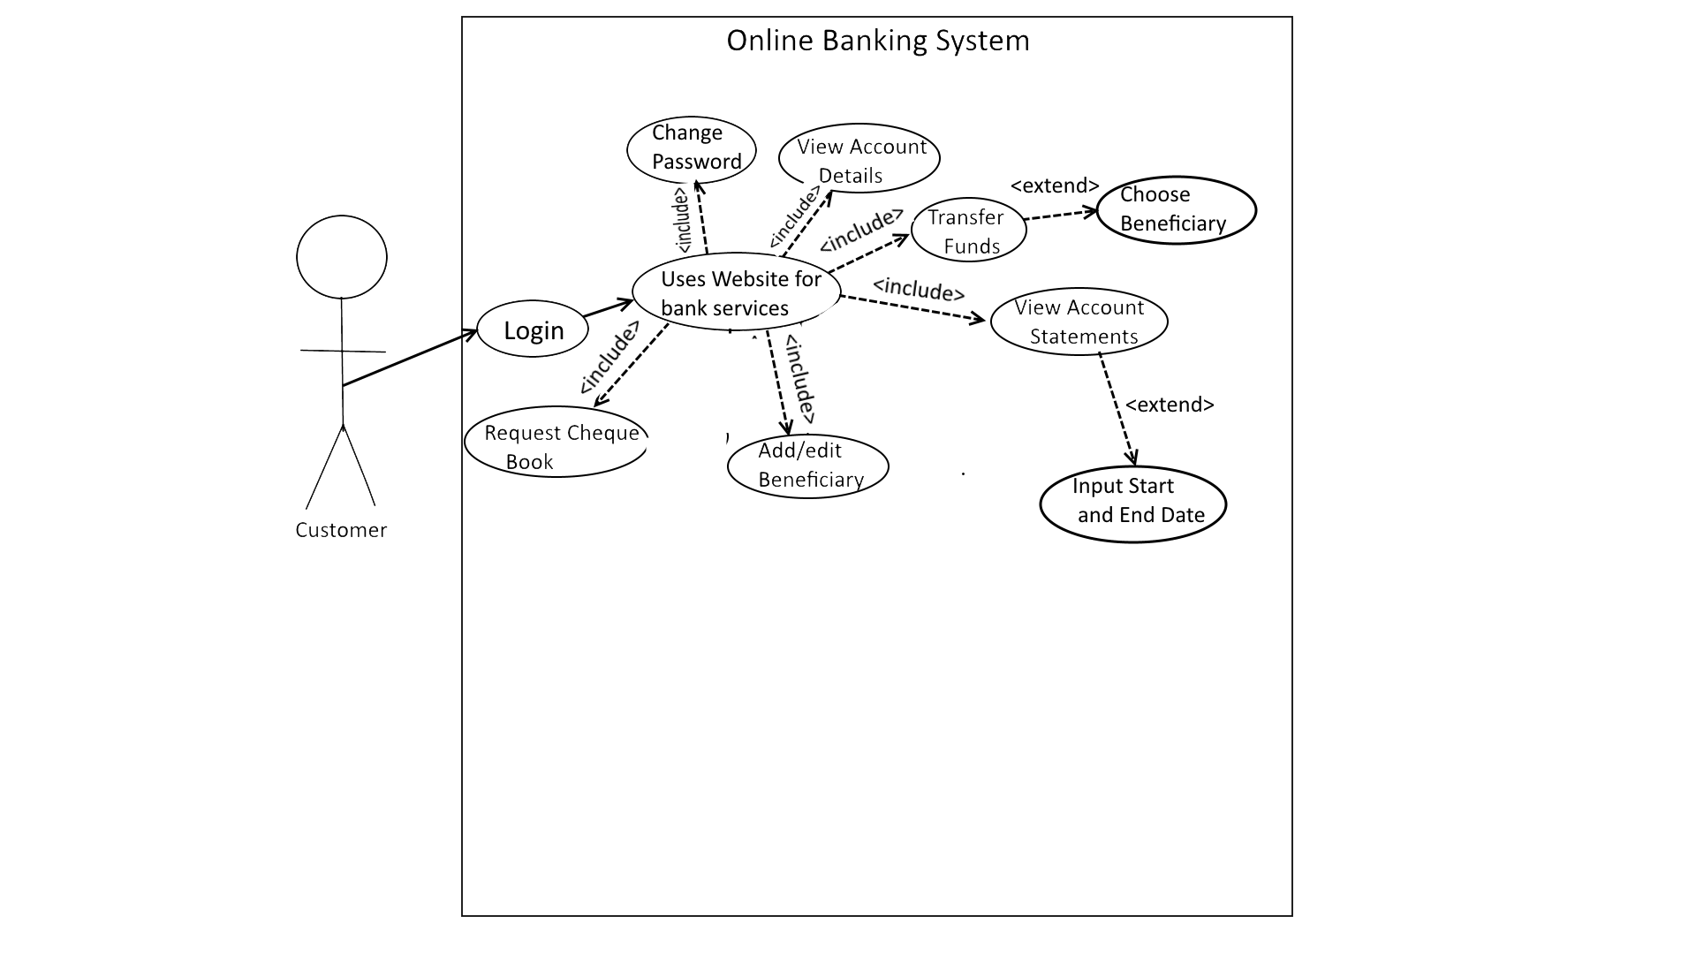

Admin:

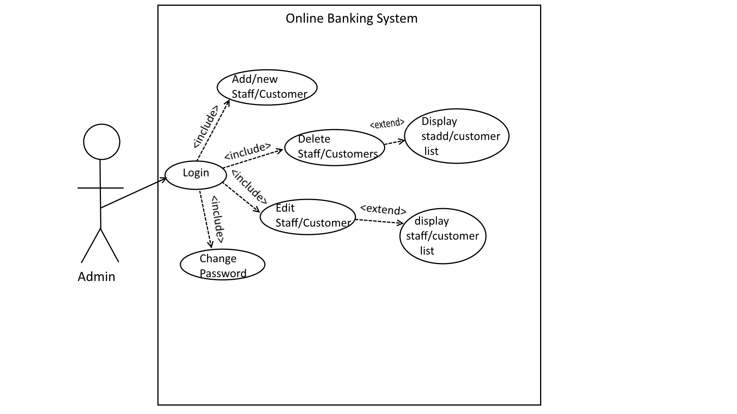

Staff:

